P

Feature / Point | Playwright | Cypress
What it is | Modern end-to-end automation tool | JavaScript E2E testing tool
Primary language support | JS/TS + Java + Python + C# | Mainly JS/TS
Browser support | Chromium, Firefox, WebKit (Safari-like) | Strong in Chromium; limited Safari/WebKit compared to Playwright
Architecture (how it runs) | Controls browsers via automation protocols (outside the browser) | Runs closer to the browser/app flow (different internal model)
Cross-browser testing | Very strong (built-in) | Possible, but comparatively limited
Multi-tab / new window handling | Strong support (tabs, popups, multiple contexts) | Traditionally limited; usually single-tab flow
Popup handling | Good support | Limited compared to Playwright
iFrame handling | Better support and smoother handling | Possible but often needs extra effort/plugins
Auto-waiting | Built-in auto-wait for actions and elements | Built-in retry/auto-wait behavior
Parallel execution | Strong built-in parallel execution support | Parallel execution possible, may depend on setup (Dashboard helps)
Debugging | Trace viewer, screenshots, videos, reports | Interactive runner + step-by-step debugging
CI/CD suitability | Very good for CI scaling and stability | Good, but setup style differs
Best suited for | Complex flows, cross-browser, multi-tab, enterprise CI | Fast local dev feedback, simpler single-tab web flows

When to choose
Situation | Better Choice | Why
Need true cross-browser testing (incl. WebKit/Safari-like) | Playwright | Built-in support for Chromium + Firefox + WebKit
App has popups / new tabs / multi-window flows | Playwright | Supports multiple tabs and contexts properly
Heavy iframe usage | Playwright | More reliable iframe support
Want best “interactive” local debugging experience | Cypress | Test runner UI is very developer-friendly
Team uses only JavaScript and wants quick setup | Cypress | Simple setup + strong dev experience
Want multi-language test support in future | Playwright | Supports Java/Python/C# too
Need strong CI parallel scaling out-of-the-box | Playwright | Parallel execution is easy with Playwright Test

Interview Script Questions & Answers: (Best for speaking in interviews)
Playwright vs Cypress
Q1) “Playwright vs Cypress — what’s the difference?”
Script (30–40 sec):
“Playwright and Cypress both are used for web UI automation. The biggest difference is capability and architecture. Playwright supports cross-browser testing very well because it runs on Chromium, Firefox, and WebKit, and it handles complex flows like multi-tabs, popups, and iframes smoothly. Cypress is JavaScript-focused and has a very strong interactive runner for debugging, which is great for developers, but it can be limited for true multi-tab scenarios. For enterprise-level cross-browser coverage and CI scalability, I usually prefer Playwright.”

Q2) “Which one is better for cross-browser testing?”
Script (15–25 sec):
“I would choose Playwright for cross-browser testing because it supports Chromium, Firefox, and WebKit out of the box. That gives wider coverage including Safari-like testing using WebKit. Cypress supports multiple browsers too, but Playwright’s cross-browser support is more complete and straightforward.”

Q3) “Your app opens a new tab during login/payment—what will you use?”
Script (15–25 sec):
“I’ll use Playwright because it supports multiple tabs, popups, and browser contexts naturally. This is common in SSO logins and payment gateways. In Cypress, multi-tab handling is not as straightforward, so for these flows Playwright is the safer choice.”

Q4) “How do you reduce flaky tests in these tools?”
Script (20–30 sec):
“Both Playwright and Cypress help reduce flakiness with auto-waiting and retries. In Playwright, I rely on built-in auto-wait and stable locators like getByRole/getByText, plus trace viewer for debugging. In Cypress, the runner is very helpful to debug step-by-step. The key is using good selectors, waiting for the right UI states, and avoiding hard waits.”

Q5) “Which tool is better for CI/CD and parallel execution?”
Script (20–30 sec):
“Playwright is very strong for CI/CD because parallel execution is built into Playwright Test and it scales easily. Cypress also supports parallel execution, but it often depends on setup and sometimes Cypress Dashboard is used for better management. For quick scaling in CI, Playwright usually feels simpler.”
Configuration of Development Environment (JavaScript + Playwright) — Full Setup (Download + Install + Run)
By the end, you will be able to install everything, create a Playwright project, download browsers, and run + debug tests.

1) What you must download (basic checklist)
You need these 3 things on your laptop:
- Node.js (LTS)
- VS Code
- Git (recommended, not mandatory)

2) Download + Install Node.js (Most important)
Step-by-step
- Open Google and search: Node.js LTS download
- Open the official Node.js site and download LTS (not “Current”)
- Install it like normal software (Next → Next → Install)
- Restart VS Code / restart PC if needed
Verify Node and npm
Open terminal (VS Code terminal or Command Prompt) and run:
- node -v
- npm -v
If both show versions, Node is installed correctly.

3) Download + Install VS Code
Step-by-step
- Search: VS Code download
- Download and install
- Open VS Code
Recommended extension
- Open VS Code → Extensions → search “Playwright Test for VS Code” → Install
This helps you run tests and debug easily.

4) Download + Install Git (Recommended)
Why Git?
Because real projects use Git to store code in repos (GitHub/Azure DevOps)
Step-by-step
- Search: Git for Windows download
- Install it (default options are fine)
- Verify:
  - git --version

5) Create your Playwright project (Proper way)
Now create your first Playwright folder.
Step-by-step
- Create a folder anywhere, example:
PlaywrightLearning
- Open VS Code → File → Open Folder → select that folder
- Open Terminal in VS Code (Terminal → New Terminal)
Now run this command (recommended):
- npm init playwright@latest
During setup it asks questions like:
- Language? (JavaScript or TypeScript)
- Test folder name? (usually tests)
- Install browsers? (Choose Yes)
- Add GitHub Actions? (Optional)
After this, Playwright setup is complete.

6) Browser download (Important to understand)
Playwright uses its own browser binaries:
- Chromium
- Firefox
- WebKit (Safari-like)
If for any reason browsers didn’t install properly, run:
- npx playwright install
This downloads browsers again.

7) What files/folders get created (so you don’t feel lost)
After installation you will see:
- package.json → your project dependencies and scripts
- playwright.config.* → main settings file (browser, timeout, reporter, etc.)
- tests/ → where your test files live
- playwright-report/ → HTML report
- test-results/ → screenshots/videos/traces (if enabled)

8) Running tests (your daily commands)
Run all tests:
- npx playwright test
Run and see browser:
- npx playwright test --headed
Run in UI mode (best for learning):
- npx playwright test --ui
Open HTML report:
- npx playwright show-report

9) Debugging (very important)
When a test fails, use these:
Option 1: Debug mode
- npx playwright test --debug
Option 2: Pause inside test
Use:
- await page.pause();
This opens Playwright Inspector so you can inspect step-by-step.
Option 3: Trace viewer
If trace is enabled in config, Playwright provides replay of steps, which is very useful for debugging.

10) Common setup problems (quick fixes)
Problem: node command not found
- Fix: reinstall Node LTS and restart terminal
Problem: browsers not downloading
- Fix: npx playwright install
- Office network issue: try home network / VPN (if allowed)
Problem: tests not running
- Fix: ensure you are in correct folder (where package.json exists)

11) Interview-ready summary (2 lines)
- “I installed Node LTS + VS Code, initialized project with npm init playwright@latest, installed browsers, and run tests using Playwright Test runner. I use headed/debug modes and reports/traces for debugging.”

Section- 2 – JavaScript Fundamentals
Module overview
- Node.js “Hello World” application
- Variables, Constants and Data Types
- Concatenation and Interpolation
- Objects and arrays
- Equality and Comparison operators
- Logical operators
- Conditional statement
- Loops
- Introduction to JavaScript Functions
- Introduction to JavaScript Classes and methods
- TypeScript vs JavaScript

“Hello World” in JavaScript
In this chapter, the goal is to confirm that the JavaScript setup works and a program can run successfully. “Hello World” is the smallest working program. If it runs properly, it means the editor, Node.js, and terminal setup are correct. Later, Playwright tests also run using the same Node environment, so this step is important.
What we cover here
We cover three basic things:
- How we write JavaScript code in a file
- How we run that file using Node.js
- How we see output in the terminal using console.log()

1) Create the first JS file
Create a file named: hello.js
Write this inside:
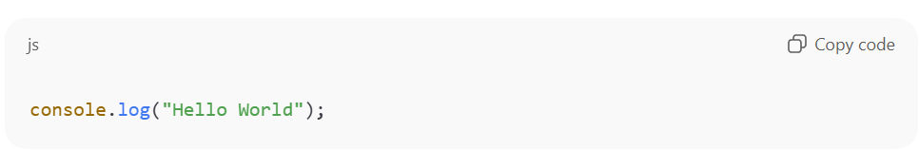
Meaning:
- console.log() prints something to the terminal.
- "Hello World" is a string (text).

2) Run it using Node.js
Open terminal inside the folder where hello.js exists and run:
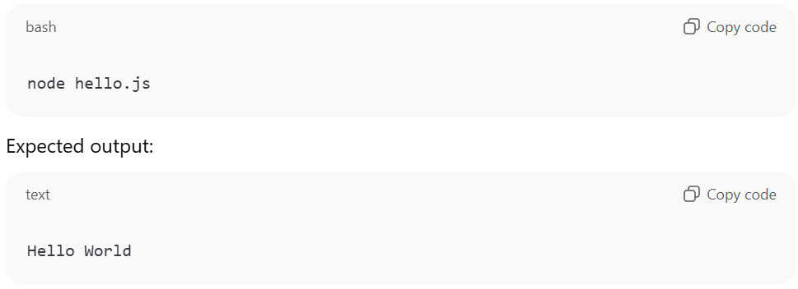If this output appears, the setup is working.

3) Common mistakes and fixes
Mistake: “node is not recognized”
Meaning: Node is not installed properly or PATH is not set.
Fix: Reinstall Node.js LTS and restart the terminal/PC.
Mistake: File not found / wrong folder
Meaning: Terminal is not opened in the folder where hello.js exists.
Fix: Navigate to the correct folder and run again.
Mistake: Typo in filename
Meaning: The command uses a different filename than the actual file.
Fix: Use the exact filename in the command.

4) Why this matters for Playwright
Playwright is executed in a similar way:
- Tests are JavaScript files
- They run using Node (npx playwright test)
So “Hello World” confirms the basic pipeline:
Write JS → Run with Node → See output

Quick mini practice
Try printing a custom message:
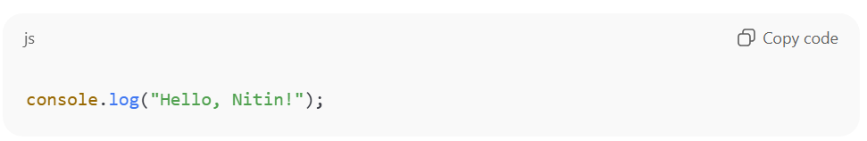
Variables, Constants and DataTypes
In JavaScript (and Playwright tests), we store values like URL, username, expected text, and flags (true/false).
For that we use variables and constants, and we must understand basic data types.

1) Variables and Constants
1.1 let (Variable)
Use let when the value can change later.
Example:
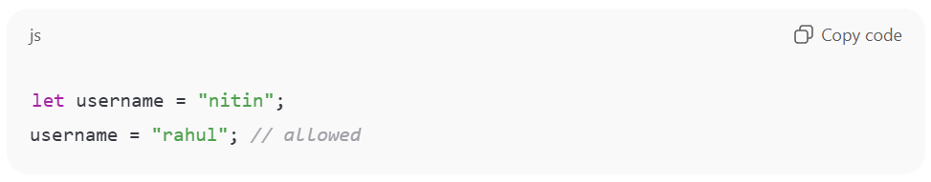1.2 const (Constant)
Use const when we should not reassign the value.
Example:
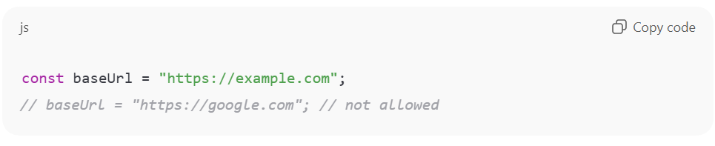Rule to follow:
- Use const by default
- Use let only when value must change

2) var (Old style)
var is older and can cause confusion due to scope behavior.
Modern JavaScript prefers const and let.
Example:
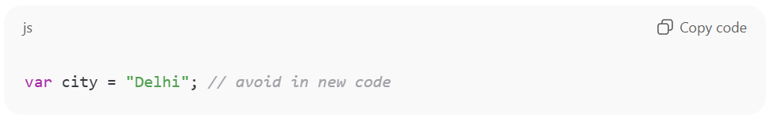
3) Data Types (Common ones)
3.1 String (Text)
Example:
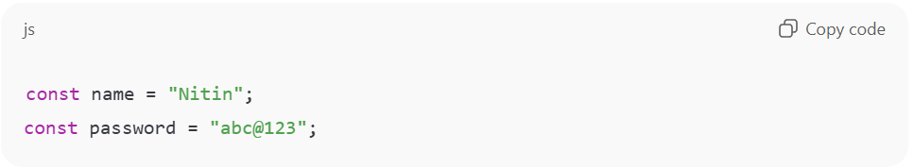3.2 Number
Example:
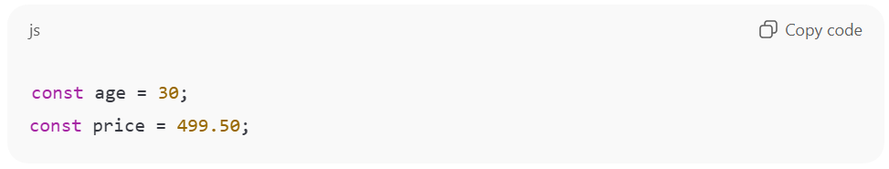3.3 Boolean (true/false)
Example:
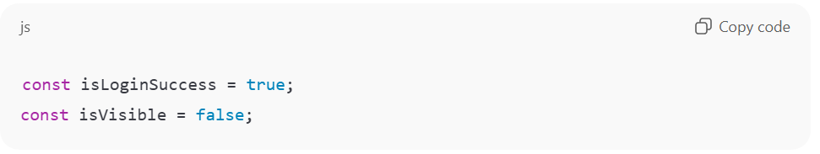3.4 Undefined (Not assigned yet)
Example:
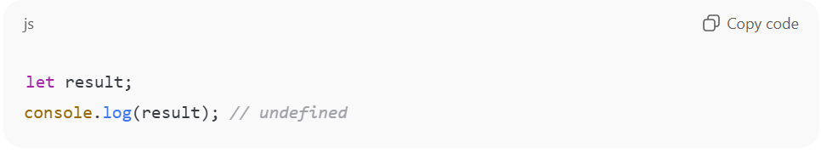3.5 Null (Intentionally empty)
Example:
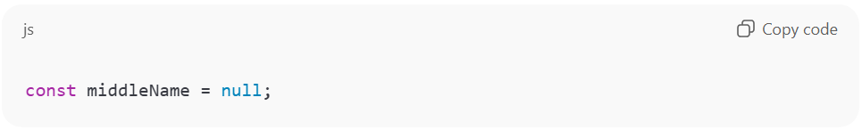3.6 Object (Key-value)
Example:
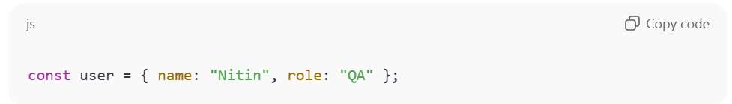3.7 Array (List of values)
Example:
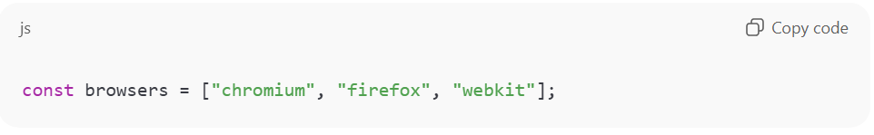
4) Checking data type using typeof
Example:
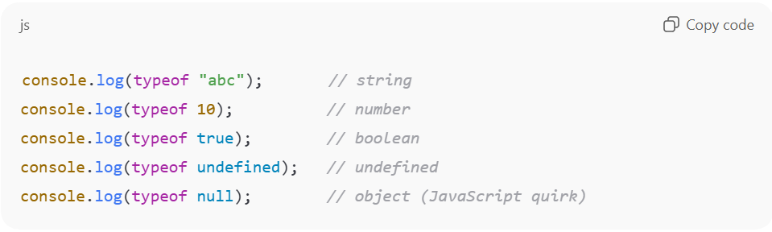Note:
- typeof null shows "object" (this is a known JavaScript behavior)

5) Why this matters in Playwright
In automation we store:
- base URL (string)
- user credentials (object)
- list of browsers (array)
- status flags like visible/enabled (boolean)
Example:
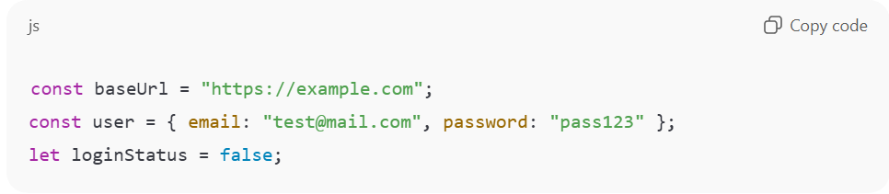
Quick Practice (Run this)
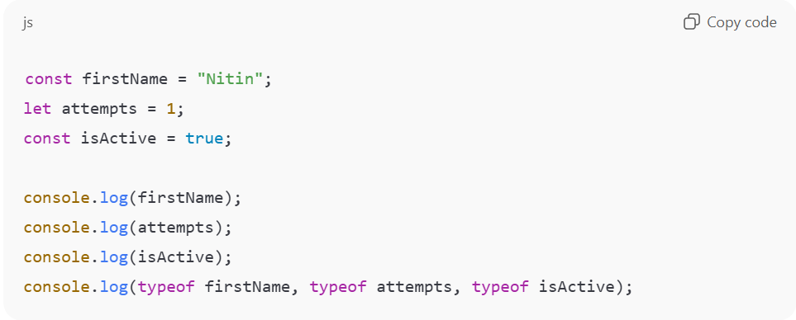
Concatenation and Interpolation
In JavaScript (and Playwright tests), we often build messages and dynamic values like URLs, selectors, logs, and expected texts. For that, we join strings using concatenation or interpolation.

1) Concatenation (Using +)
Concatenation means joining strings using the + operator.
Example:
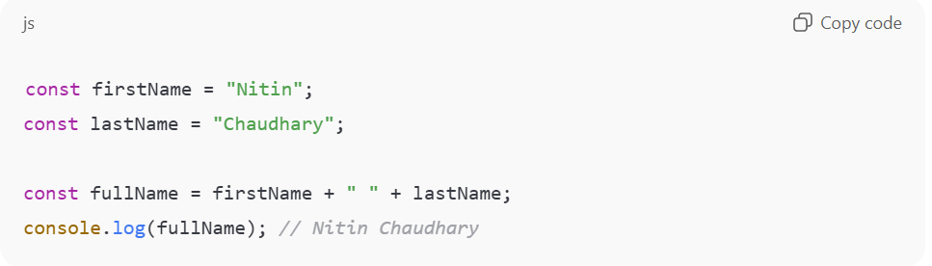Common example:
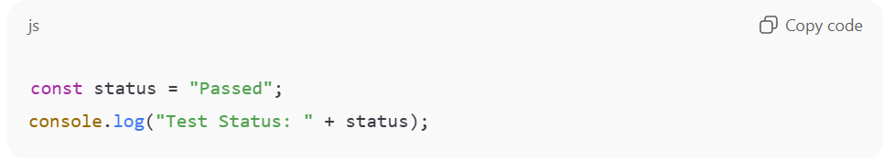Important note:
- If a number is added with a string, JavaScript converts the number to string.
Example:
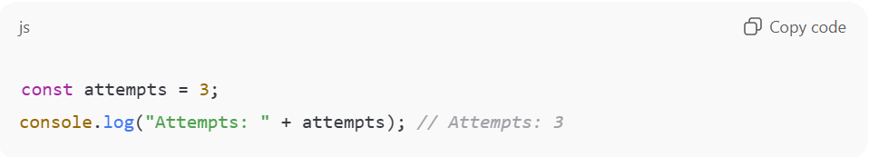
2) Interpolation (Template Literals using backticks )
Interpolation means inserting variables inside a string using template literals.
Syntax:
- Use backticks:
- Put variable inside: ${variable}
Example:
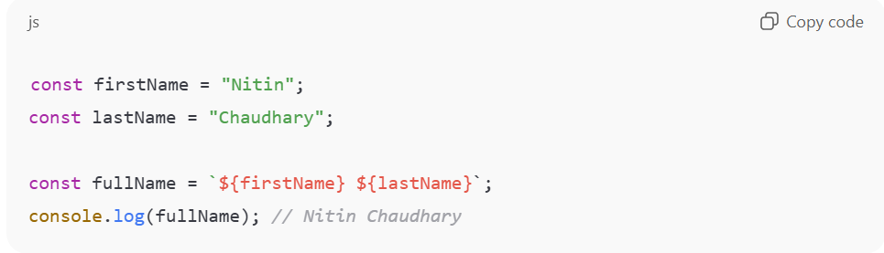
Common example:
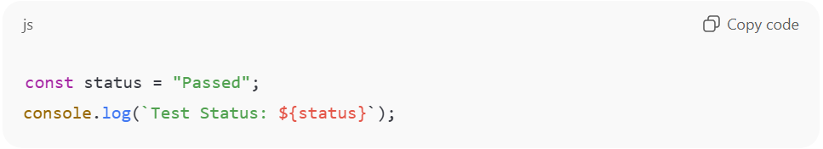
3) Why interpolation is preferred
Interpolation is preferred because:
- It is cleaner and more readable
- It avoids too many + signs
- It works nicely with multi-line strings
Multi-line example:
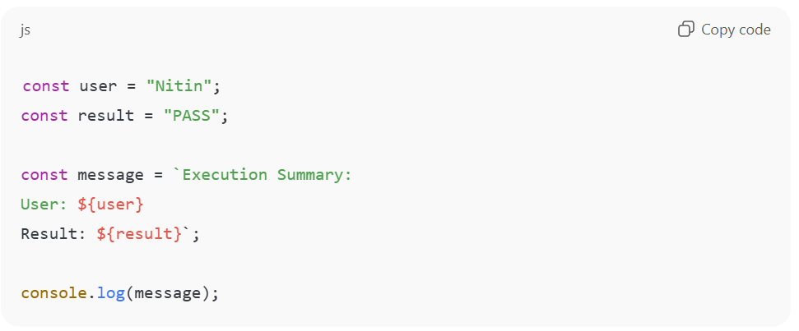
4) Real Playwright-style examples
Example 1 (Logging):
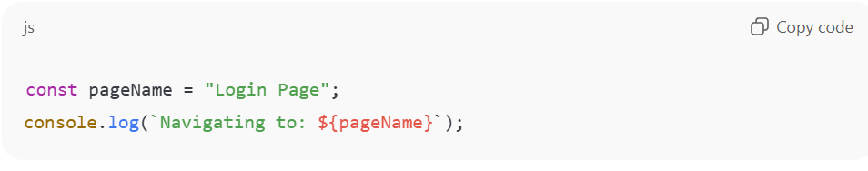Example 2 (Building a URL):
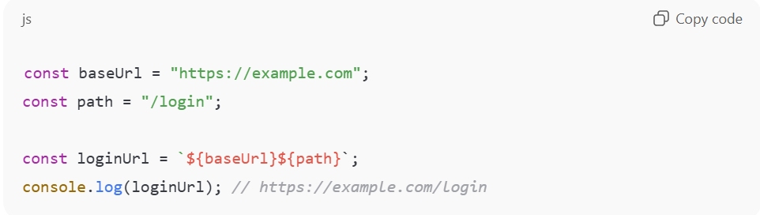Example 3 (Expected message):
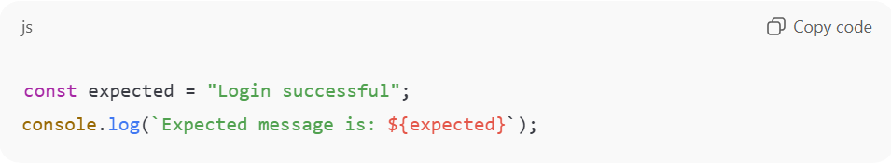
5) Common mistakes
Mistake 1: Using quotes instead of backticks
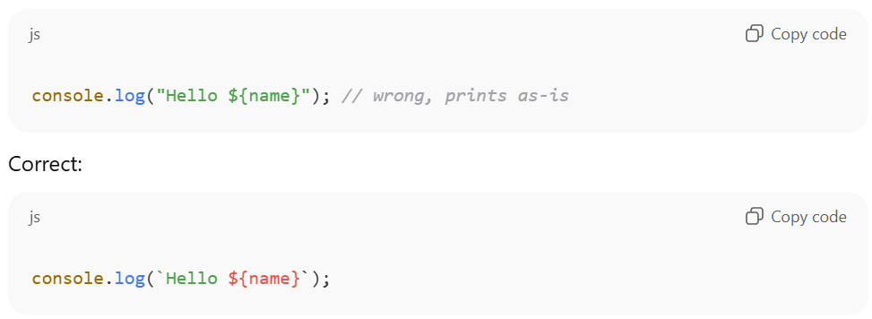Mistake 2: Missing ${ }
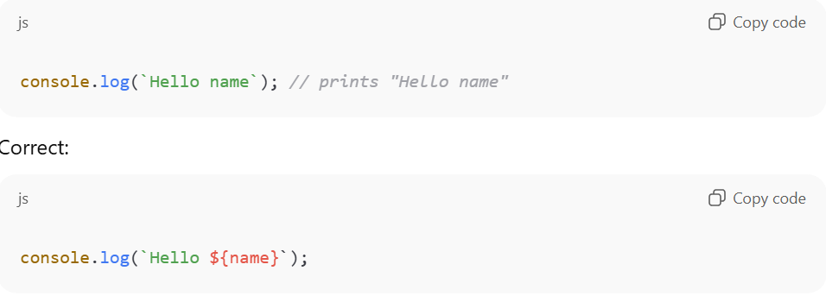
Quick Practice (Run this)
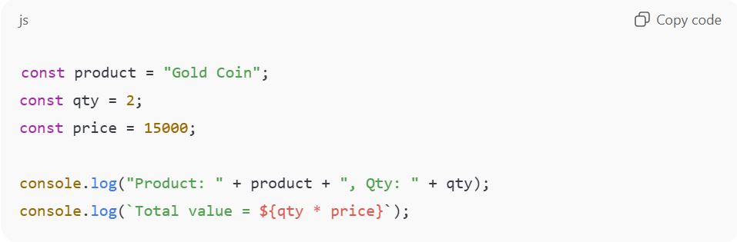
Objects & Arrays
In JavaScript (and Playwright automation), we often work with structured data.
- Objects are used to store related information in key-value form (like a user profile).
- Arrays are used to store a list of values (like multiple browsers, multiple users, multiple test data sets).

1) Objects (Key-Value Data)
1.1 What is an object?
An object stores data as property: value pairs.
Example:
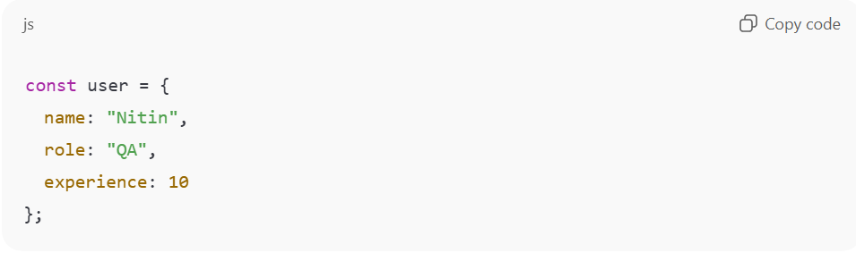1.2 How to access object values
Using dot notation:
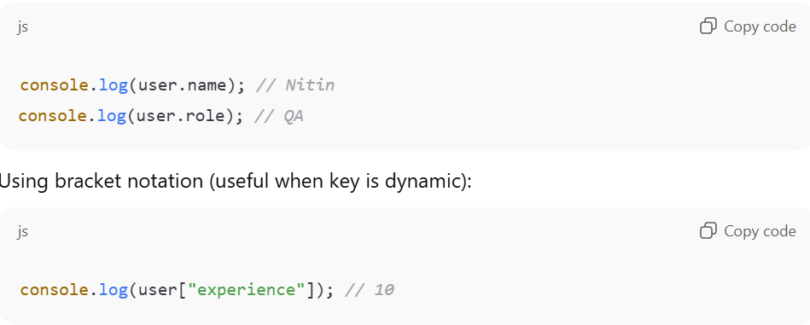1.3 Updating object values
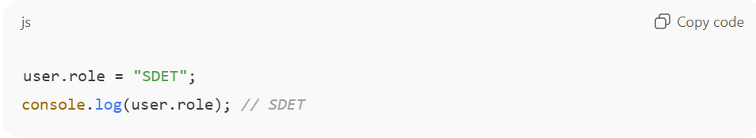1.4 Adding a new property
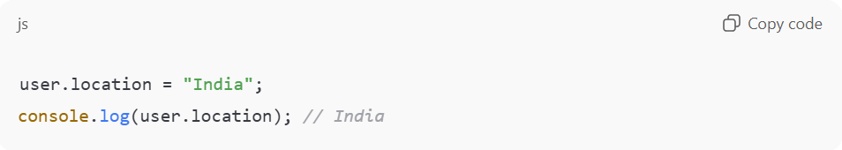1.5 Object with nested object (common in real data)
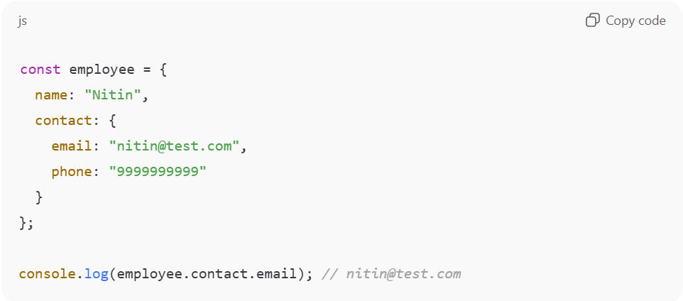
2) Arrays (List of Values)
2.1 What is an array?
An array stores values in an ordered list.
Example:
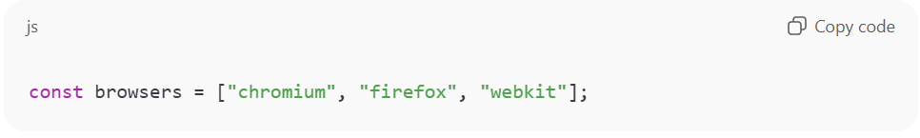2.2 Access array values using index
Index starts from 0:
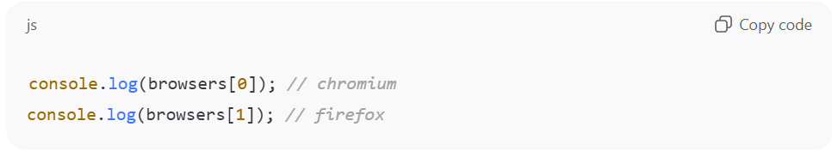2.3 Common array operations
Add at the end:
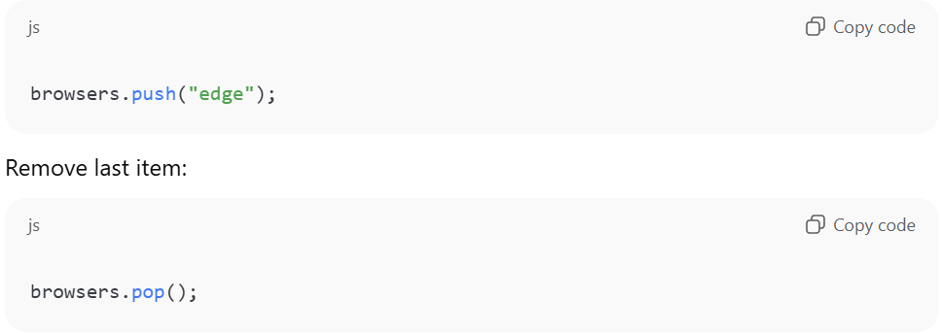Get length:
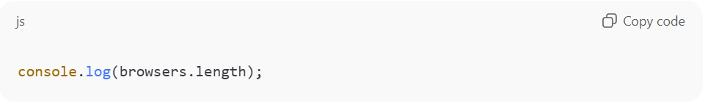
3) Looping through an array (very common)
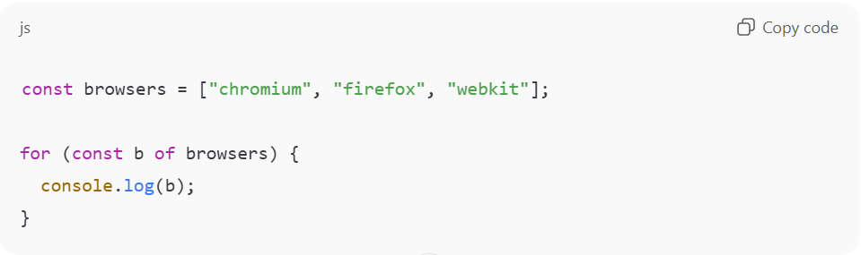
4) Array of Objects (Most useful in automation)
This is used for test data sets.
Example:
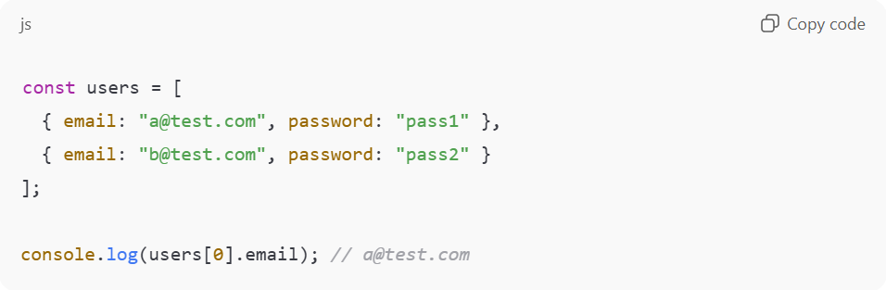Loop and print:
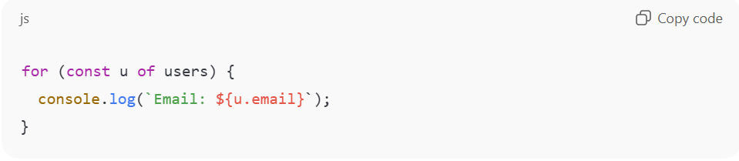
5) Real Playwright-style examples
Example 1: Storing test data as object
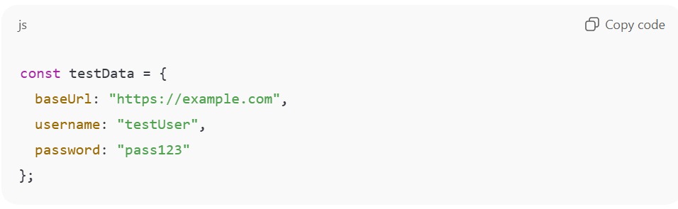Example 2: Storing multiple values as array
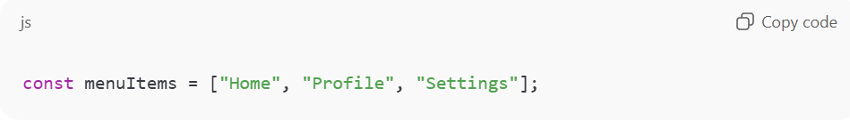Example 3: Multiple users for data-driven testing
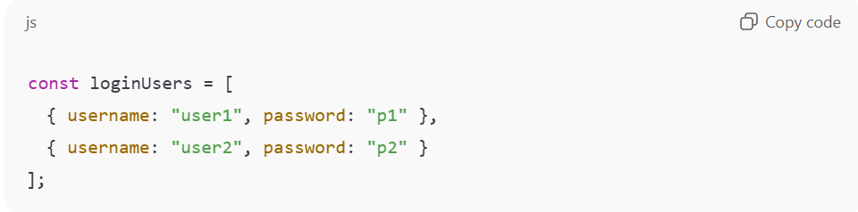
6) Common mistakes
Mistake 1: Using wrong key name
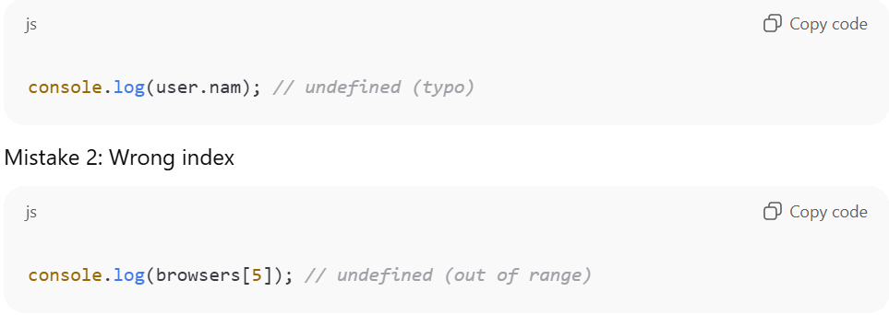
Quick Practice
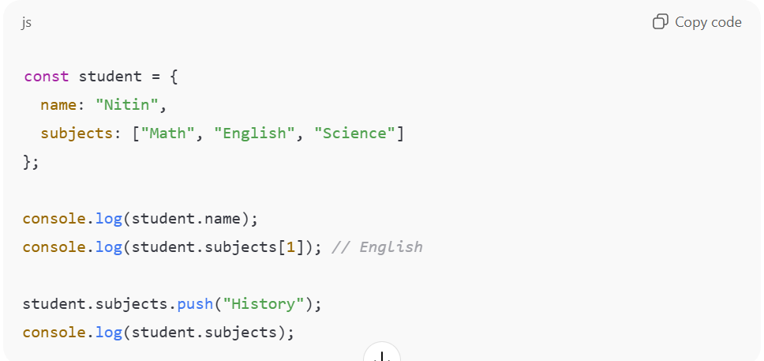
Relational and Equality Operators
In JavaScript, operators help us compare values and make decisions. In Playwright automation, we use these comparisons all the time—for validating expected vs actual text, checking counts, verifying status codes, and deciding what action to take next.

1) Relational Operators (Compare “greater/less”)
Relational operators compare two values and return a boolean (true/false).
Operators and meaning
- > greater than
- < less than
- >= greater than or equal
- <= less than or equal
Equality operators compare “same or not same”.
- === strict equality (best for automation)
- !== strict not equal
- == loose equality (avoids type checking, can surprise us)
- != loose not equal
Examples
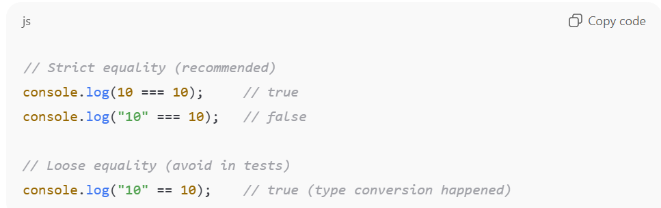
Realistic usage
const retryCount = 2;
console.log(retryCount <= 3); // true
String relational comparison (lexicographic / dictionary order)
console.log("b" > "a"); // true
console.log("10" > "2"); // false (string comparison, not numeric)
Important note
If both are strings, comparison is based on character order, not numeric value. For numeric comparisons, ensure values are numbers.

2) Equality Operators (Compare “same/not same”)
There are two types of equality checks in JavaScript:
A) Loose equality: == and !=
- Compares values after type conversion.
- Can cause unexpected results.
Examples
console.log(5 == "5"); // true
console.log(0 == false); // true
console.log(null == undefined); // true
B) Strict equality: === and !== (Recommended)
- Compares value AND type.
- Most reliable for real projects and automation.
Examples
console.log(5 === "5"); // false
console.log(0 === false); // false
console.log(null === undefined); // false
console.log(5 !== "5"); // true
Rule to follow
- Use === and !== in automation unless there is a special reason.

3) Playwright-style examples (how it connects)
Example 1: Compare expected vs actual text
const actual = "Login successful";
const expected = "Login successful";

if (actual === expected) {
console.log("Validation passed");
} else {
console.log("Validation failed");
}
Example 2: Verify count is greater than zero
const records = 3;

if (records > 0) {
console.log("Records found");
} else {
console.log("No records found");
}

4) Common mistakes
Mistake 1: Using == and getting unexpected true
console.log("" == 0); // true (unexpected for beginners)
Mistake 2: Comparing numbers as strings
console.log("10" > "2"); // false (string compare)
Fix: Convert to number
console.log(Number("10") > Number("2")); // true

Quick Practice
const a = 10;
const b = "10";

console.log(a == b); // ?
console.log(a === b); // ?
console.log(a >= 5); // ?
console.log(a < 5); // ?

Chapter 11: Logical Operators (JavaScript)
Overview
Logical operators combine multiple conditions. In Playwright, we use them to check multiple validations together—like visible AND enabled, or login success OR error message.

1) AND operator &&
Both conditions must be true.
Examples
console.log(true && true); // true
console.log(true && false); // false
Automation-style example
const isVisible = true;
const isEnabled = true;

if (isVisible && isEnabled) {
console.log("We can click the element");
}

2) OR operator ||
At least one condition must be true.
Examples
console.log(true || false); // true
console.log(false || false); // false
Automation-style example
const isChrome = false;
const isFirefox = true;

if (isChrome || isFirefox) {
console.log("Run test on supported browser");
}

3) NOT operator !
Reverses boolean value.
Examples
console.log(!true); // false
console.log(!false); // true
Automation-style example
const isErrorVisible = false;

if (!isErrorVisible) {
console.log("No error shown, continue flow");
}

4) Short-circuit behavior (very important)
AND &&
- If first condition is false, second is not evaluated.
OR ||
- If first condition is true, second is not evaluated.
Example
const a = false;
const b = () => console.log("runs");

a && b(); // b() will not run

5) Common mistakes
Mistake: Using & instead of &&
- & is bitwise operator, not logical AND.
Correct
if (x > 0 && y > 0) { }

Quick Practice
const isLoggedIn = true;
const isAdmin = false;

console.log(isLoggedIn && isAdmin); // ?
console.log(isLoggedIn || isAdmin); // ?
console.log(!isAdmin); // ?

Chapter 12: Conditional Statements (JavaScript)
Overview
Conditional statements control program flow. In automation, conditions help handle dynamic cases like optional popups, different environments, or different user roles.

1) if statement
const age = 20;

if (age >= 18) {
console.log("Allowed");
}

2) if...else
const isLoggedIn = false;

if (isLoggedIn) {
console.log("Go to dashboard");
} else {
console.log("Go to login");
}

3) else if ladder
const score = 75;

if (score >= 90) {
console.log("Grade A");
} else if (score >= 70) {
console.log("Grade B");
} else {
console.log("Grade C");
}

4) Switch statement (useful for fixed options)
const browser = "chromium";

switch (browser) {
case "chromium":
console.log("Run on Chromium");
break;
case "firefox":
console.log("Run on Firefox");
break;
default:
console.log("Unsupported browser");
}

5) Ternary operator (short if-else)
const isVisible = true;
const msg = isVisible ? "Visible" : "Not Visible";
console.log(msg);

6) Playwright-style example (popup handling idea)
const isPopupVisible = false;

if (isPopupVisible) {
console.log("Close popup");
} else {
console.log("Continue");
}

Common mistakes
Mistake: Using = instead of ===
if (x = 5) { } // wrong (assignment)
Correct
if (x === 5) { }

Quick Practice
const value = 15;

if (value > 20) console.log("High");
else if (value >= 10) console.log("Medium");
else console.log("Low");

Chapter 13: Loops (JavaScript)
Overview
Loops repeat actions. In automation, loops help handle lists, multiple test data sets, multiple items in table, and repetitive validations.

1) for loop (most common)
for (let i = 1; i <= 3; i++) {
console.log(i);
}

2) while loop
let i = 1;
while (i <= 3) {
console.log(i);
i++;
}

3) do...while loop
Runs at least once.
let i = 1;
do {
console.log(i);
i++;
} while (i <= 3);

4) for...of loop (best for arrays)
const browsers = ["chromium", "firefox", "webkit"];

for (const b of browsers) {
console.log(b);
}

5) forEach (array method)
const items = ["A", "B", "C"];

items.forEach((item) => {
console.log(item);
});

6) Break and continue
Break stops loop.
for (let i = 1; i <= 5; i++) {
if (i === 3) break;
console.log(i);
}
Continue skips one iteration.
for (let i = 1; i <= 5; i++) {
if (i === 3) continue;
console.log(i);
}

7) Playwright-style example (data driven idea)
const users = ["user1", "user2"];

for (const u of users) {
console.log(`Testing login for ${u}`);
}

Common mistakes
Mistake: Infinite loop (forgetting increment)
let i = 1;
while (i <= 3) {
console.log(i);
// i++ missing => infinite loop
}

Quick Practice
const nums = [2, 4, 6, 8];
let sum = 0;

for (const n of nums) {
sum = sum + n;
}
console.log(sum);

Chapter 14: Functions (JavaScript)
Overview
Functions are reusable blocks of code. In automation, functions reduce duplication: login steps, navigation, common validations, waits, and data formatting.

1) Function declaration
function greet(name) {
return `Hello ${name}`;
}

console.log(greet("Nitin"));

2) Function expression
const add = function(a, b) {
return a + b;
};

console.log(add(2, 3));

3) Arrow function (modern and common)
const multiply = (a, b) => a * b;
console.log(multiply(2, 5));

4) Default parameters
function printRole(role = "QA") {
return role;
}

console.log(printRole());
console.log(printRole("SDET"));

5) Return vs no return
Return gives output to caller.
function square(n) {
return n * n;
}
console.log(square(4));
No return means function ends without value.
function logMsg(msg) {
console.log(msg);
}
logMsg("Hello");

6) Async functions (important for Playwright)
Playwright uses async/await.
Example format:
const doSomething = async () => {
// await some async steps
};

7) Playwright-style example (reusable login)
const login = async (page, username, password) => {
await page.fill("#username", username);
await page.fill("#password", password);
await page.click("#login");
};

Common mistakes
Mistake: forgetting return when needed
function add(a, b) {
a + b; // no return
}
Correct:
function add(a, b) {
return a + b;
}

Quick Practice
const isEven = (n) => n % 2 === 0;

console.log(isEven(4));
console.log(isEven(5));

Chapter 15: Classes and Methods (JavaScript)
Overview
Classes are used to organize code. In automation, classes are commonly used for Page Object Model (POM): each page becomes a class with locators and actions (methods).

1) Basic class and method
class User {
constructor(name, role) {
this.name = name;
this.role = role;
}

getDetails() {
return `${this.name} - ${this.role}`;
}
}

const u1 = new User("Nitin", "QA");
console.log(u1.getDetails());

2) this keyword meaning
this refers to the current object created from the class.
Example:
class Car {
constructor(brand) {
this.brand = brand;
}
}

const c = new Car("Honda");
console.log(c.brand);

3) Playwright POM style example (very common)
class LoginPage {
constructor(page) {
this.page = page;
this.username = "#username";
this.password = "#password";
this.loginBtn = "#login";
}

async login(user, pass) {
await this.page.fill(this.username, user);
await this.page.fill(this.password, pass);
await this.page.click(this.loginBtn);
}
}
How it is used:
// const loginPage = new LoginPage(page);
// await loginPage.login("user", "pass");

Common mistakes
Mistake: forgetting new
const u = User("Nitin", "QA"); // wrong
Correct:
const u = new User("Nitin", "QA");

Quick Practice
class Calculator {
add(a, b) { return a + b; }
}

const c = new Calculator();
console.log(c.add(2, 3));

Chapter 16: TypeScript vs JavaScript
Overview
JavaScript is dynamically typed. TypeScript adds type safety on top of JavaScript. Many Playwright projects use TypeScript because it improves maintainability and reduces runtime issues.

1) JavaScript example (no types enforced)
let value = "10";
value = 10; // allowed

2) TypeScript example (types enforced)
let value: number = 10;
// value = "10"; // not allowed

3) Benefits of TypeScript (in automation)
- Catch type errors during development (before running tests)
- Better autocomplete and IDE support
- Easier to maintain large test frameworks
- Clear function inputs/outputs

4) When to choose what
JavaScript is fine when:
- small learning projects
- quick scripts
TypeScript is better when:
- framework is large
- team work and long-term maintenance is needed

Quick Practice mindset
If project is long-term or team-based, TypeScript usually pays off.

If you want, next I can add for each chapter: 5 interview Q&A scripts (speaking format) like we did for Playwright vs Cypress, but for these JavaScript topics.

